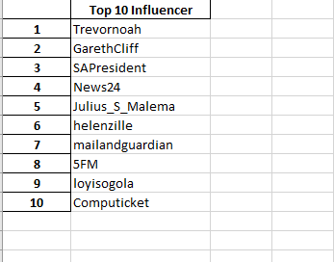**THE TOP INFLUENCER**

**THE TOP 10 AFRICAN LEADER**

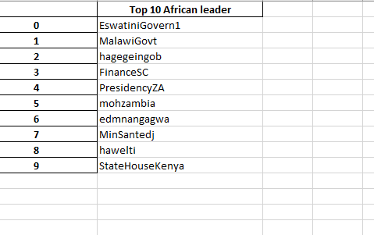

Those are the top 10 users